SRI CHANDRASEKHARENDRA SARASWATHI VISWA MAHAVIDYALAYA
(UNIVERSITY ESTABLISHED UNDER SECTION 3 OF UGC ACT 1956)
ENATHUR, KANCHIPURAM – 631 561

DEPARTMENT OF COMPUTER SCIENCE & ENGINEERING



NAME | K.KEERTHI
REGISTER NUMBER | 11259A217
SECTION | S4 (BE-CSE)/AI&DS
SUBJECT | FML LAB

SINO | NAME OF THE EXPERIMENT | DATES
1. | DATA PREPROCESSING IN GIVEN DATASET | 07/08/2026
 | DATA SPLIT AND CROSS -VALIDATION
 | IMPLEMENT LINEAR REGRESSION
 | IMPLEMENT CLASSIFICATION MODEL USING SVM AND COMPUTE EVALUATION METRICS
 | IMPLEMENT HIERARCHICAL CLUSTERING
 | IMPLEMENT RANDOM FOREST AND ANALYZE PERFORMANCE
 | IMPLEMENT BOOSTING TECHNIQUE (ADABOOST) AND ANALYZE PERFORMANCE
 | IMPLEMENT A BASIC REINFORCEMENT LEANRING MODEL (Q-LEARNING)

EXPNO1: Data Preprocessing

AIM :- To preprocess the dataset by handling missing values and normalizing the numerical features using standard scaler for efficient data analysis and machine learning.

Algorithm:

- Start
- Load the dataset.
- Check the dataset for missing values.
- Remove duplicate records.
- Handle missing values by replacing them with suitable values.
- Remove unwanted or unnecessary data.
- Convert categorical data into numerical data.
- Normalize or standardize the data.
- Split the dataset into training and testing data.
- Stop

Program:

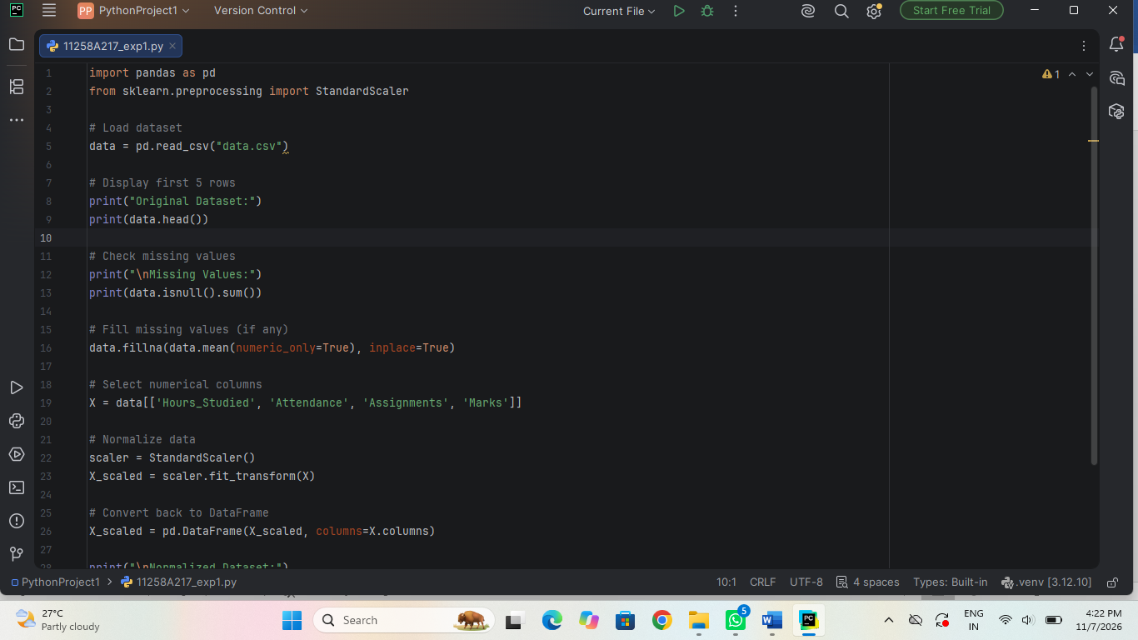

Output:

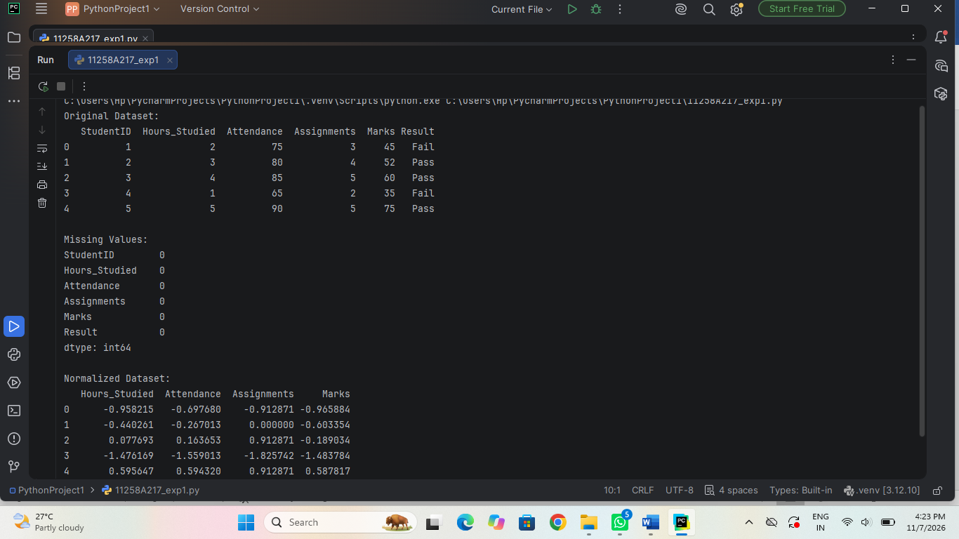

Result:

The dataset was successfully preprocessed ,missing values were replaced with appropriate mean values, and the numerical features were normalized to a standard scale with mean 0 and standard deviation 1.

EXPNO2(i): Data Splitting

AIM :- To split the given dataset into training and testing dataset for building and evaluating a machine learning model.

Algorithm:

- Start
- Load the dataset.
- Separate input features (X) and target variable (Y).
- Select the splitting ratio (80% training and 20% testing).
- Split the dataset into training and testing data.
- Store 80% of data for training.
- Store 20% of data for testing.
- Use training data to train the machine learning model.
- Use testing data to evaluate the model.
- Stop

Program:

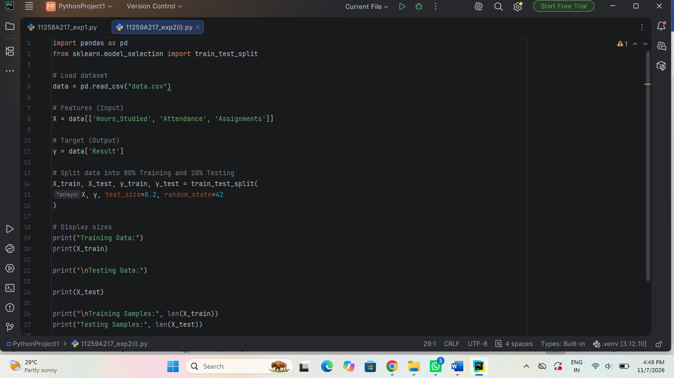

Output:

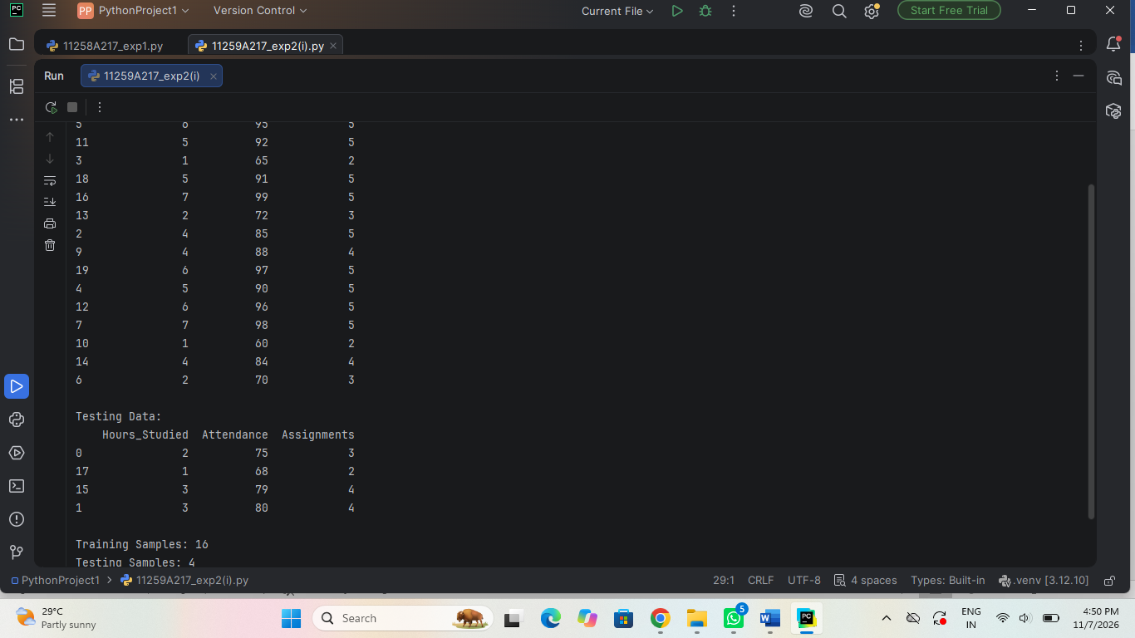

Result:

The data set was successfully split, and the KNN model was evaluated using 5-fold cross validation .The accuracy scores were obtained successfully.

(ii) Data Split up and Cross validation.

AIM:- To split the dataset into training and testing sets and evaluate the KNN model using cross validation.

Algorithm:

- Start
- Load the preprocessed dataset.
- Separate input features (X) and target variable (Y).
- Divide the dataset into training data (80%) and testing data (20%).
- Apply K-Fold Cross Validation on the training data.
- Divide the training data into K equal parts (folds).
- Use one fold for validation and the remaining folds for training.
- Repeat the process until every fold is used for validation.
- Calculate the accuracy for each fold.
- Find the average accuracy of all folds.
- Train the final model using the training data.
- Evaluate the model using testing data.
- Stop

Program:

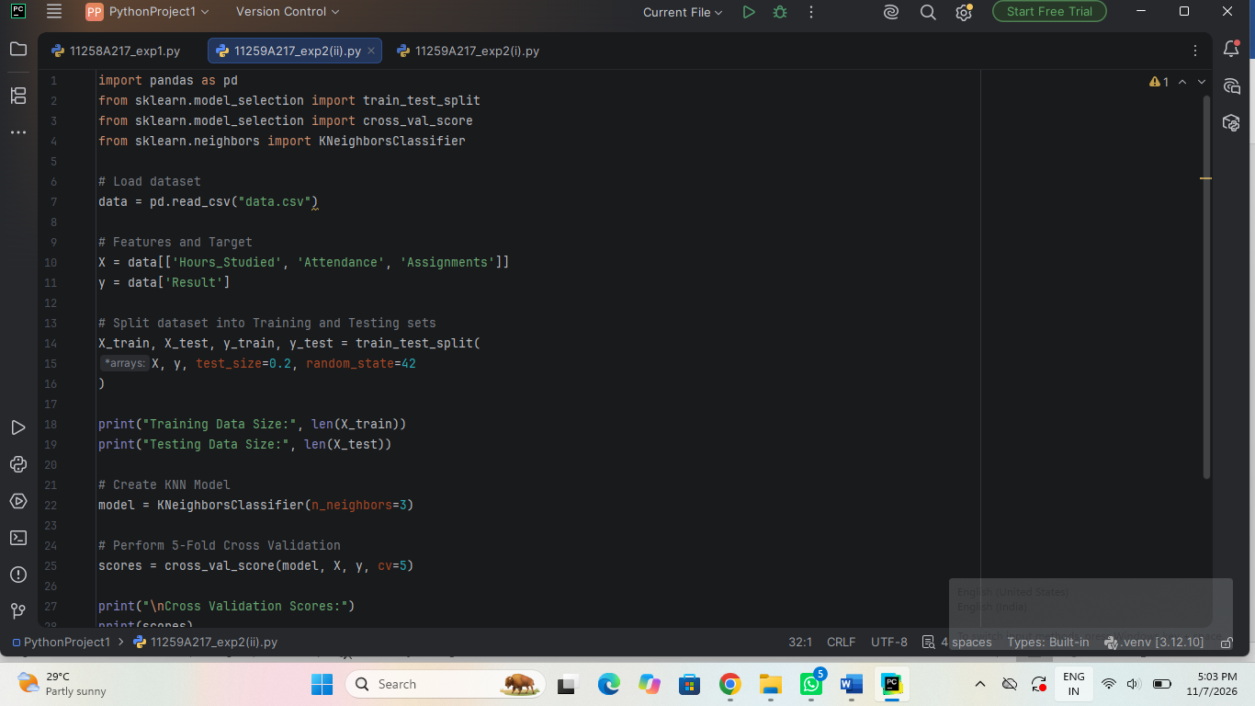

Output:

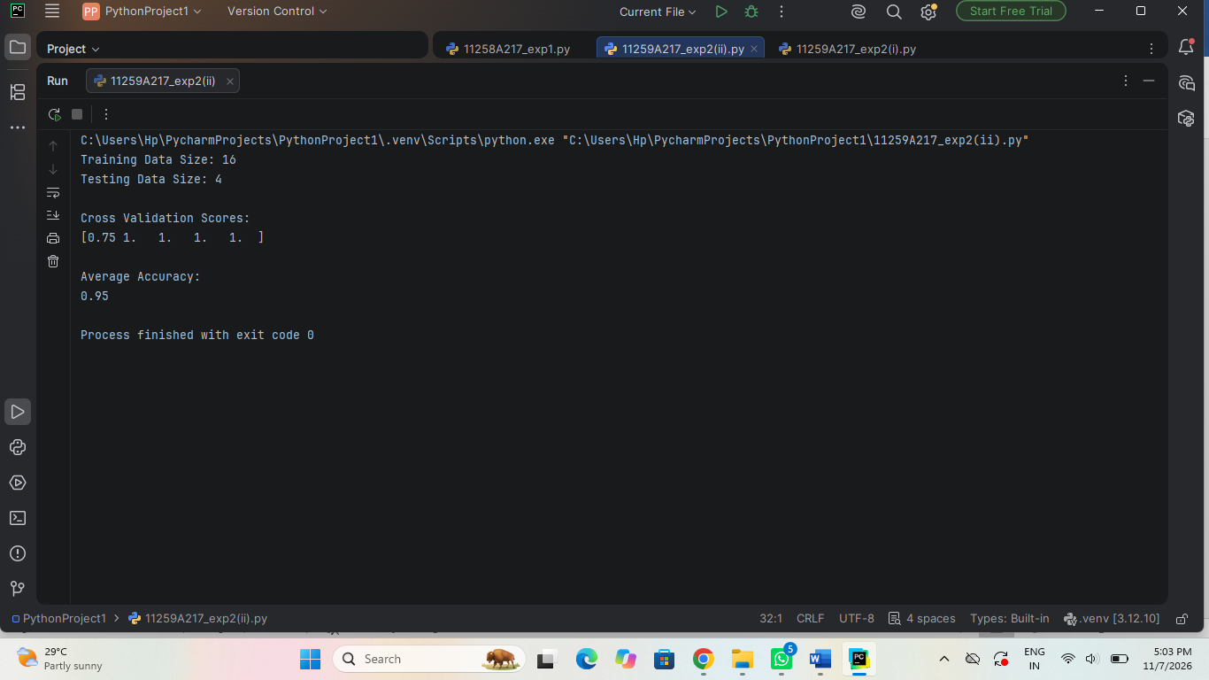

Result:

The dataset was successfully split, and the KNN model was evaluated using 5-fold cross validation . The accuracy scores were obtained successfully.

EXPNO 3: Implement Linear Regression

AIM:- To implement linear regression to predict students marks obtain based on the number of hours studied and evaluate the model’s performance.

Algorithm:

- Start
- Load the dataset.
- Select input features (X) and target variable (Y).
- Split the dataset into training and testing data.
- Create a Linear Regression model.
- Train the model using training data.
- Find the best-fit regression line.
- Predict the output using testing data.
- Calculate model performance using evaluation metrics.
- Display the predicted results.
- Stop

Program:

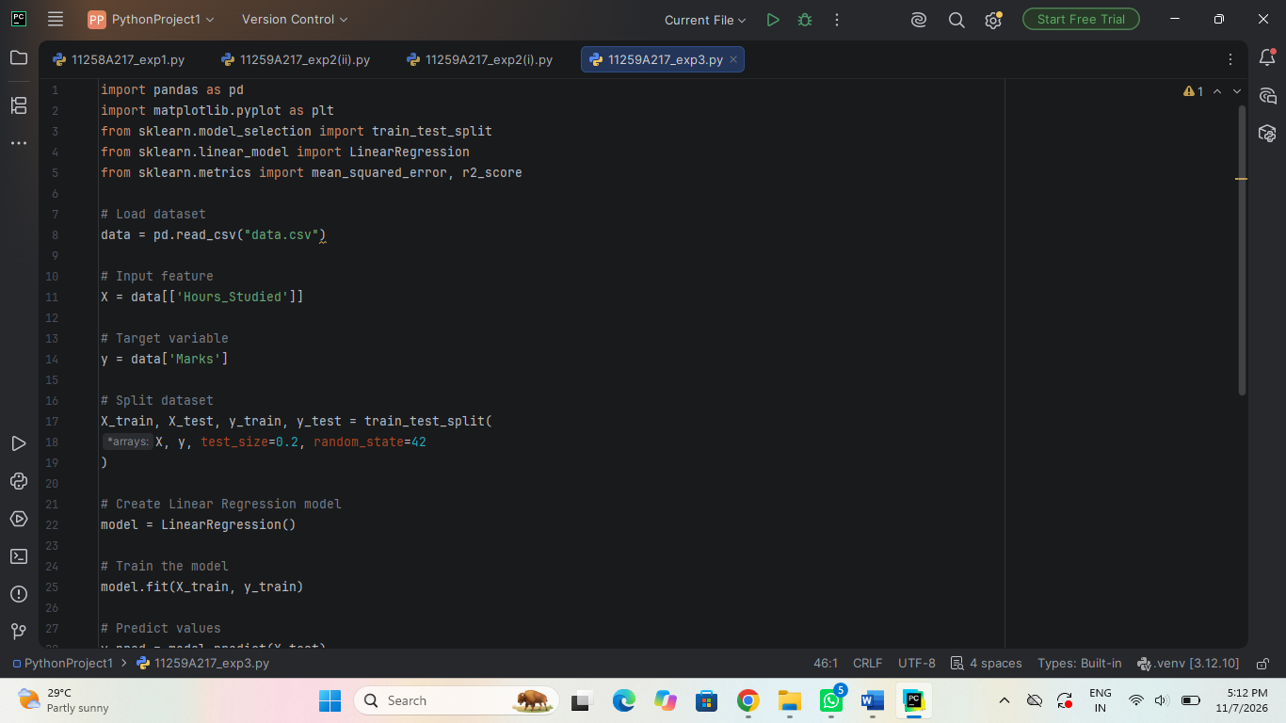

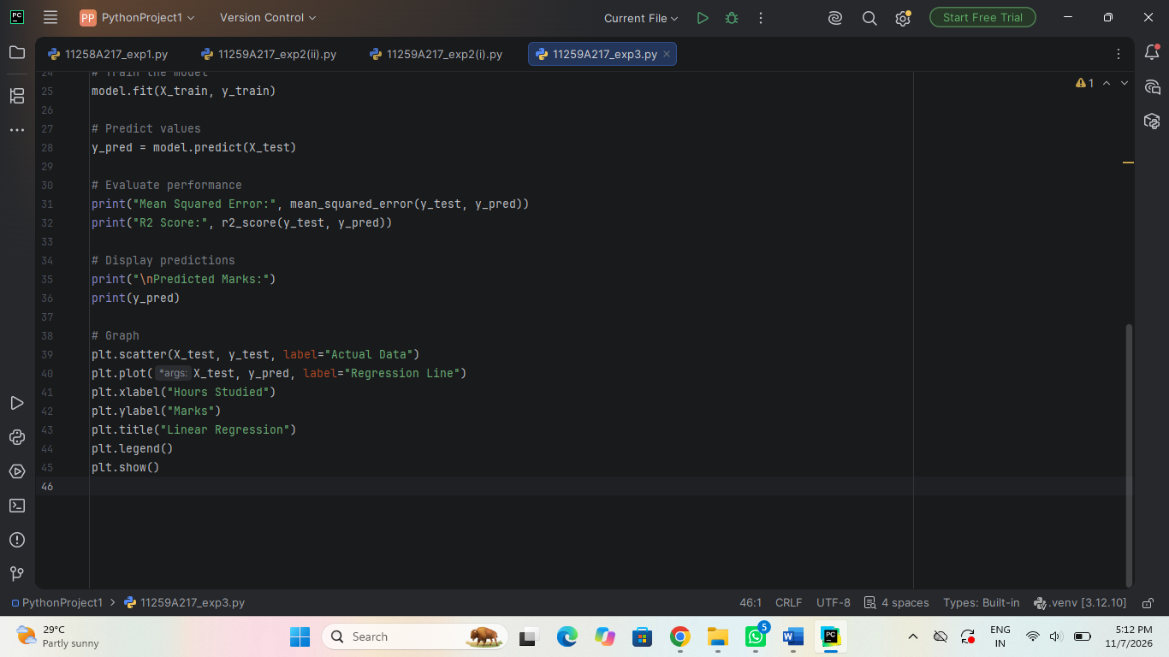

Output:

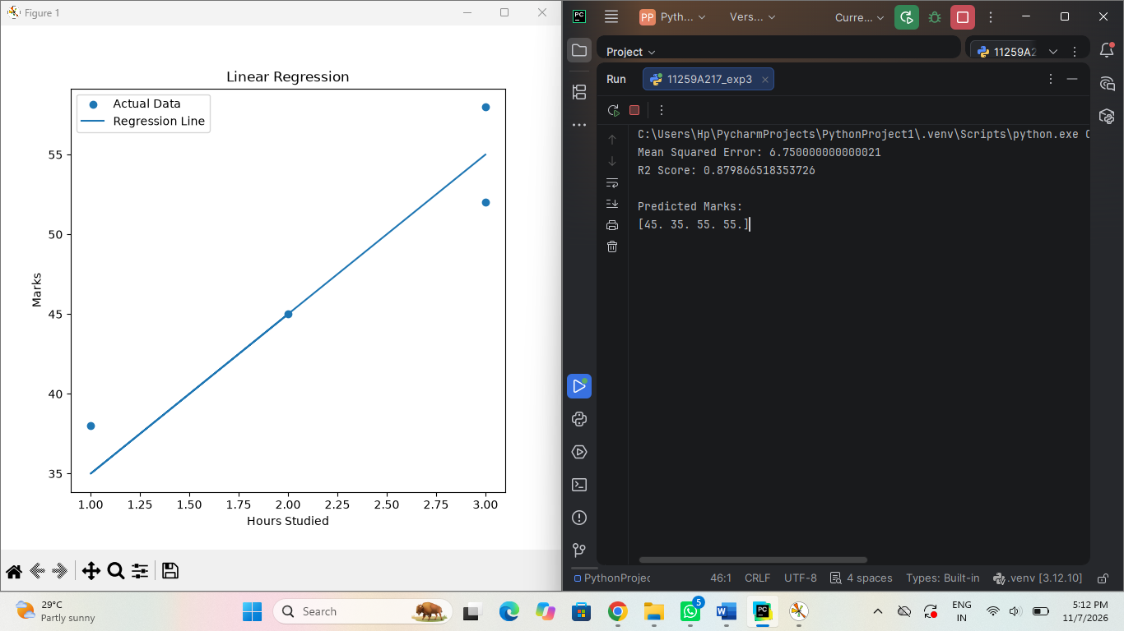

Result:
The linear regression model was successfully implemented .thus , the students marks were successfully predicted using linear regression based on the hours studied.

EXPNO 4(i): Implement Classification Model Using KNN and Compute Evaluation Metrics

AIM:- To implement a classification model using support vector machine (SVM) and compute the evaluation metrics to measure the model performance.

Algorithm:

- Start
- Load the dataset.
- Preprocess the dataset by handling missing values.
- Separate input features (X) and target variable (Y).
- Split the dataset into training and testing data.
- Choose the value of K (number of nearest neighbours.
- Create the KNN classification model.
- Train the model using training data.
- Predict the class labels using testing data.
- Calculate evaluation metrics such as Accuracy, Precision, Recall and F1-Score.
- Display the evaluation results.
- Stop

Program:

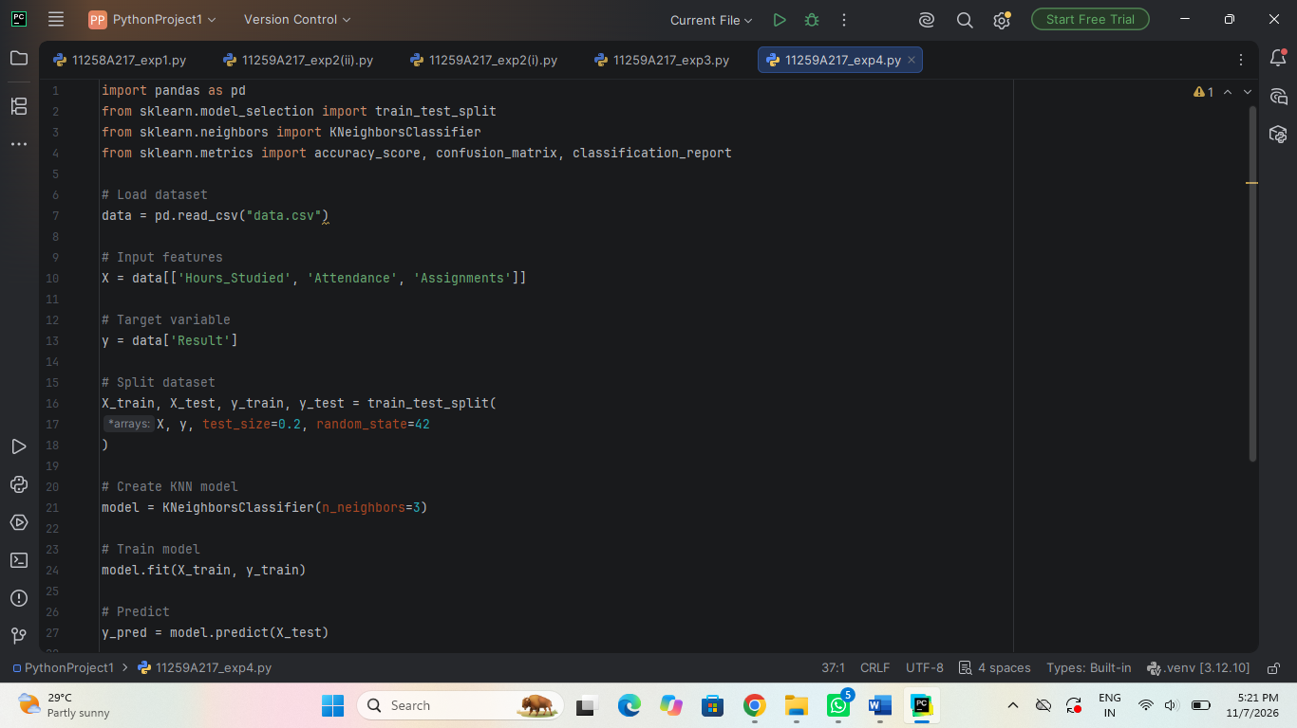

Output:

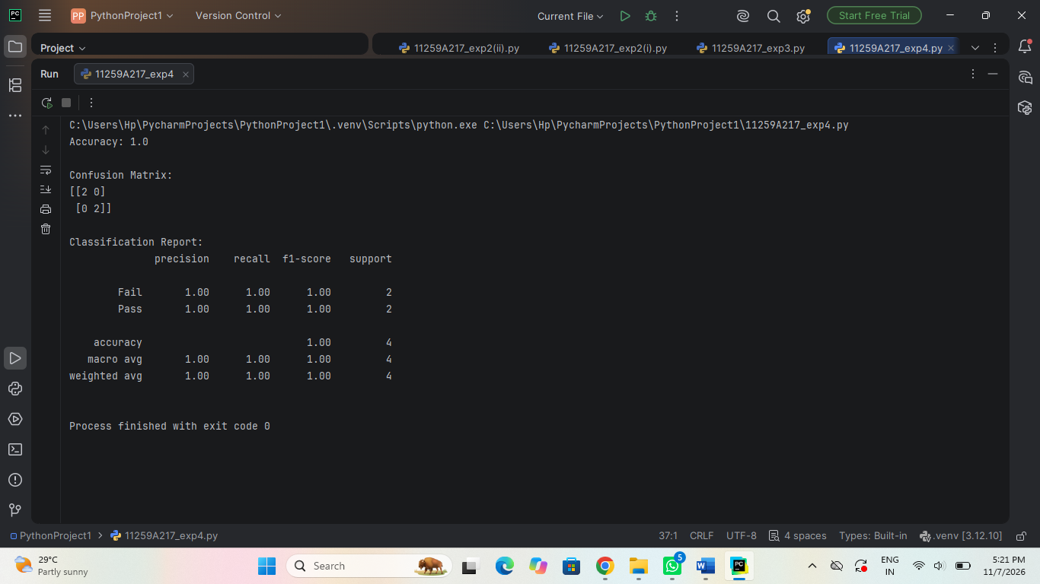

Result:

The SVM classification model was successfully implemented. The model was evaluated using suitable evaluation metrics , and its performance was successfully determined.

EXPNO4(ii): Implement Classification Model Using SVM and Compute Evaluation Metrics

AIM:- To implement a classification model using support vector machine (SVM) and compute the evaluation metrics to measure the model performance.

Algorithm:

- Start
- Load the dataset.
- Preprocess the dataset by handling missing values.
- Separate input features (X) and target variable (Y).
- Split the dataset into training and testing data.
- Apply feature scaling to the data.
- Create the SVM classification model.
- Train the model using training data.
- Predict the class labels using testing data.
- Calculate evaluation metrics such as Accuracy, Precision, Recall and F1-Score.
- Display the evaluation results.
- Stop

Program:

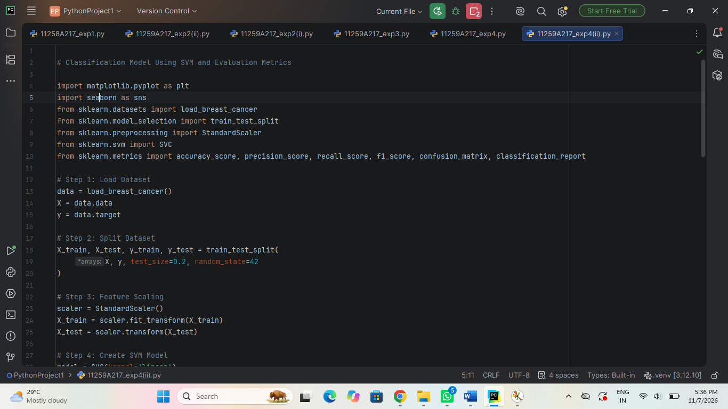

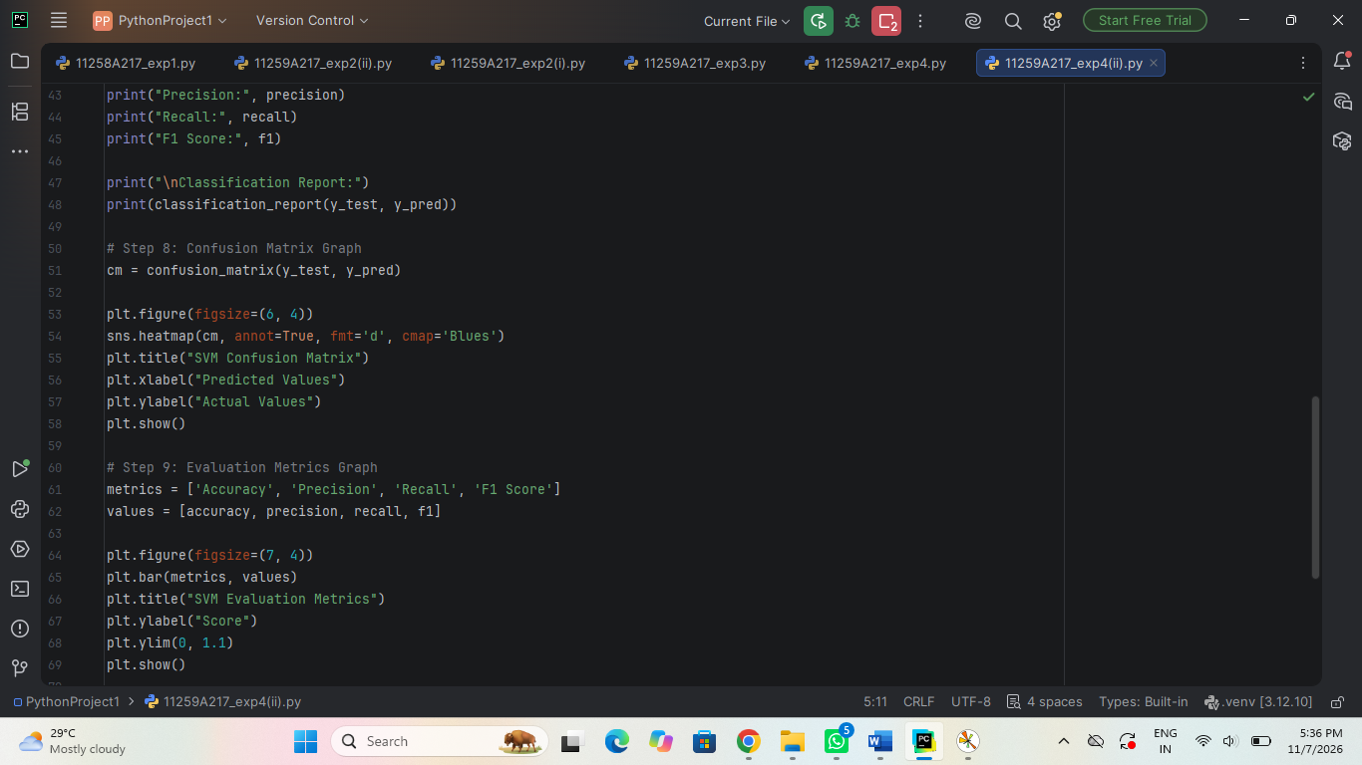

Output:

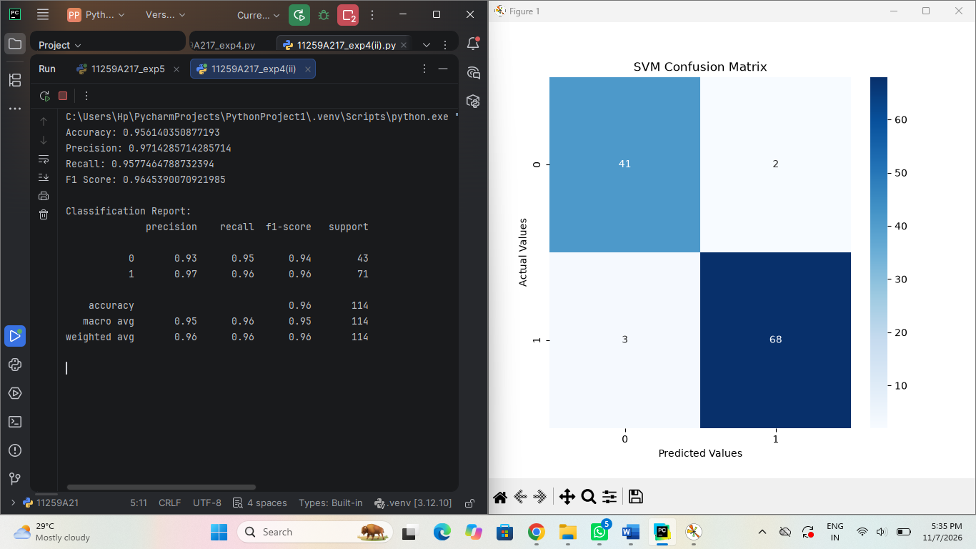

Result:

The SVM classification model was successfully implemented. The model was evaluated using suitable evaluation metrics , and its performance was successfully determined.

EXPNO5: Implement K-Means Clustering

AIM:- To implement the K-means clustering algorithm to group data into clusters based on Hours studied and Marks.

Algorithm:

- Start
- Load the dataset.
- Preprocess the dataset by handling missing values.
- Select the required features.
- Choose the number of clusters (K).
- Initialize K random centroids.
- Calculate the distance between each data point and centroids.
- Assign each data point to its nearest centroid.
- Recalculate the centroids based on the assigned data points.
- Repeat the process until the centroids become stable.
- Display the final clusters using a graph.
- Stop

Program:

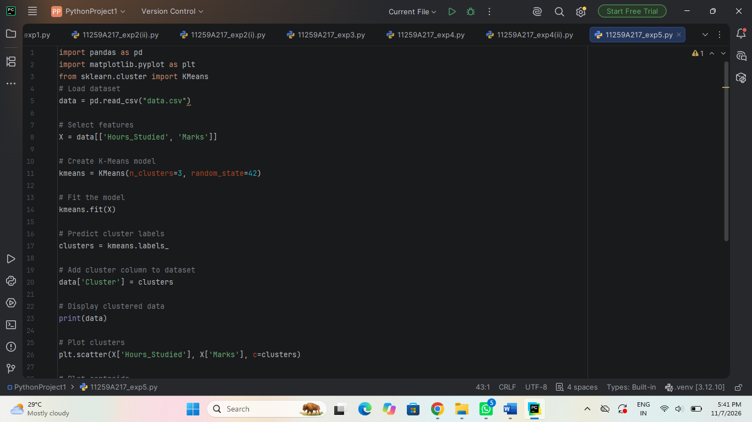

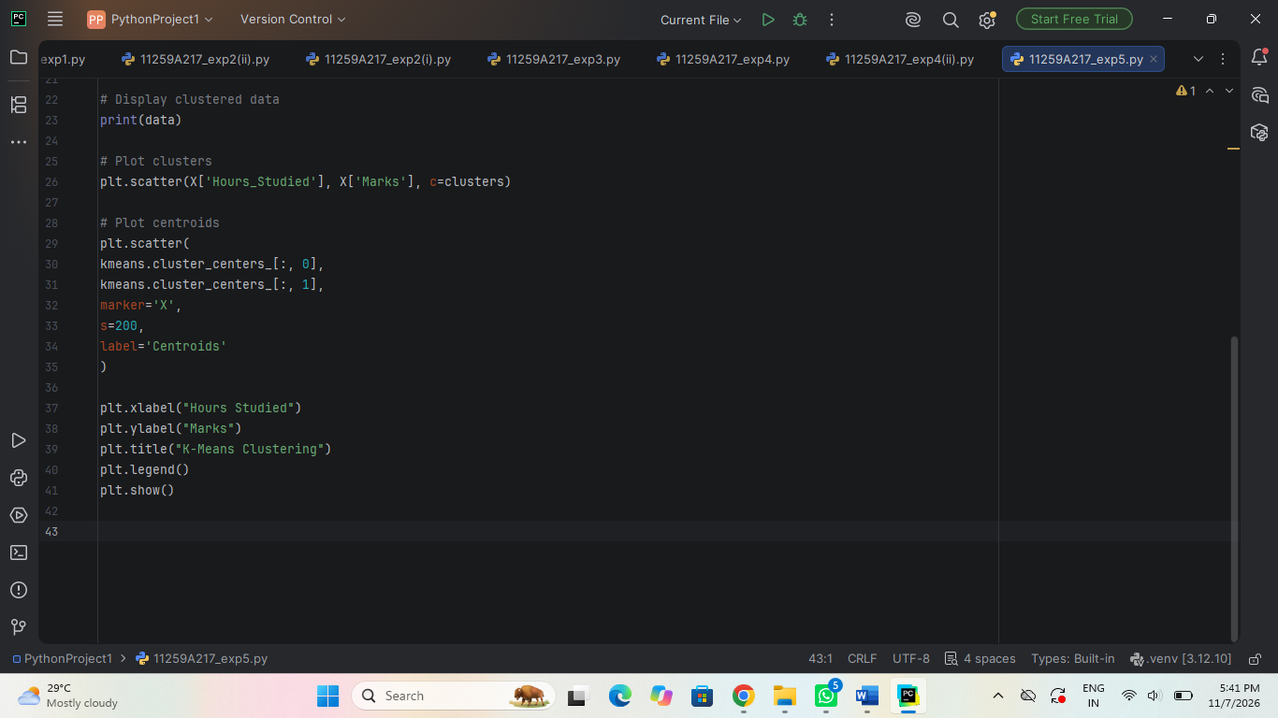

Output:

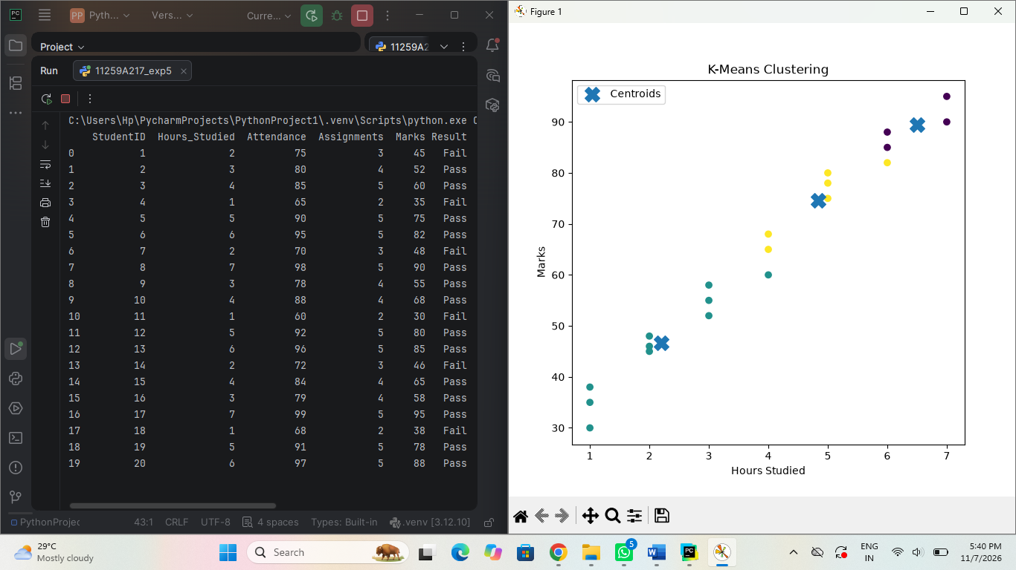

Result:

The K-means clustering model successfully grouped the data into 3 clusters , and the cluster along with their centroids were displayed graphically.

EXPNO6: Implement Hierarchical Clustering

AIM:- To implement Hierarchical clustering using the agglomerative clustering algorithm and group the data based on Hours studied and Marks.

Algorithm:

- Start
- Load the dataset.
- Preprocess the dataset by handling missing values.
- Select the required features.
- Calculate the distance between data points.
- Consider each data point as a separate cluster.
- Merge the two nearest clusters.
- Recalculate the distance between clusters.
- Repeat the process until all data points form a single cluster.
- Draw the dendrogram to display the clusters.
- Stop

Program:

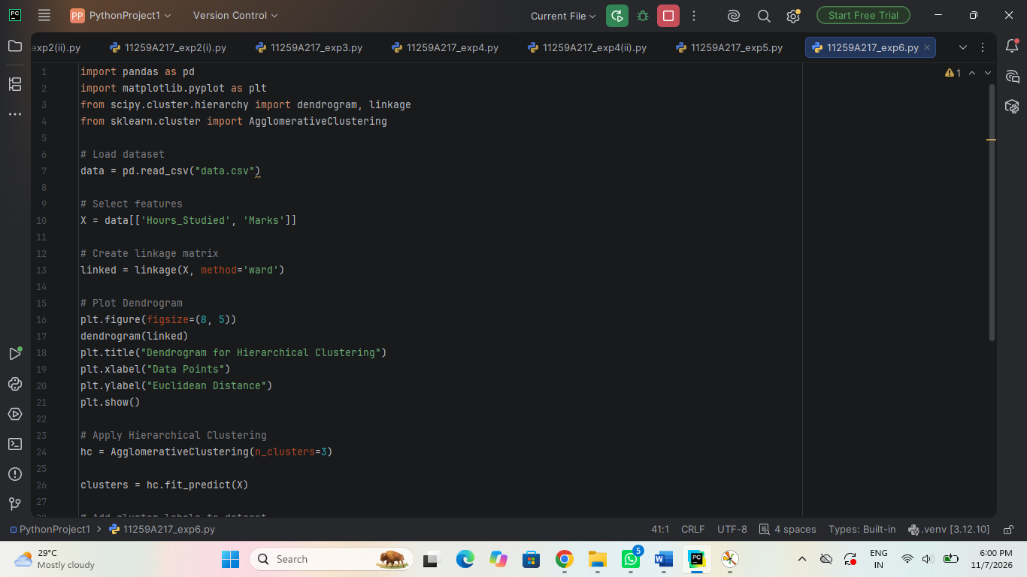

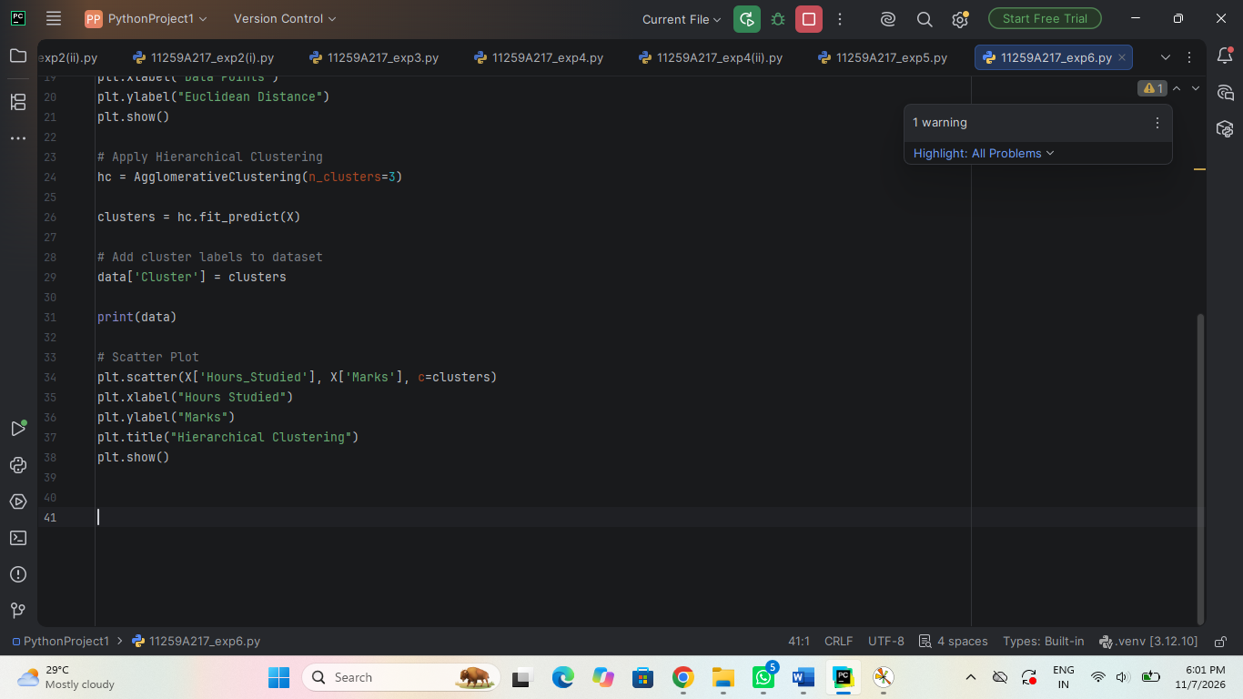

Output:

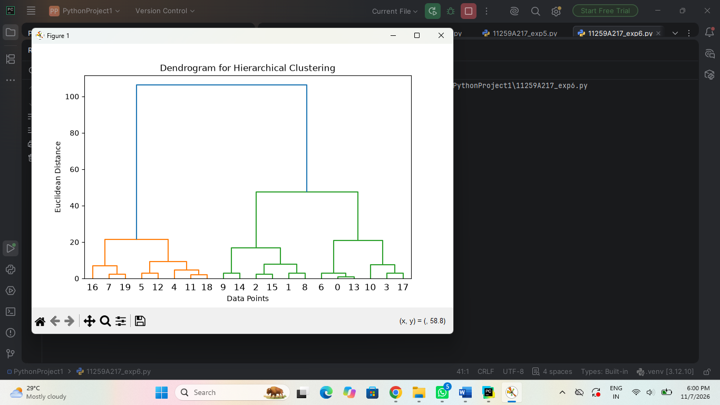

Result:

Hierarchical clustering using the agglomerative clustering algorithm was successfully implemented.

EXPNO7: Implement Random Forest and Analyze Performance

AIM:- To implement the random forest classification algorithm using python to predict student results (pass/fail) based on Hours studied . Attendance and Assignments and to evaluate the mode’s performance.

Algorithm:

- Start
- Load the dataset.
- Preprocess the dataset by handling missing values.
- Separate input features (X) and target variable (Y).
- Split the dataset into training and testing data.
- Create the Random Forest model.
- Train the model using training data.
- Predict the output using testing data.
- Calculate evaluation metrics such as Accuracy, Precision, Recall and F1-Score.
- Analyze the model performance.
- Display the evaluation results using graphs.
- Stop

Program:

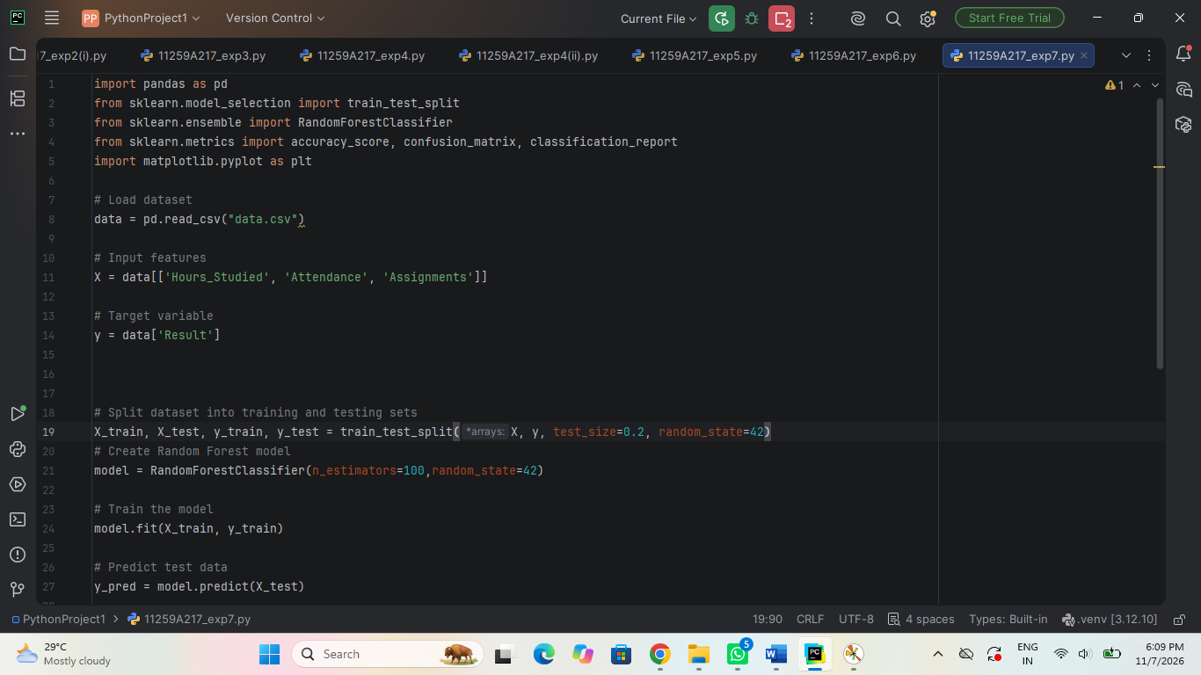

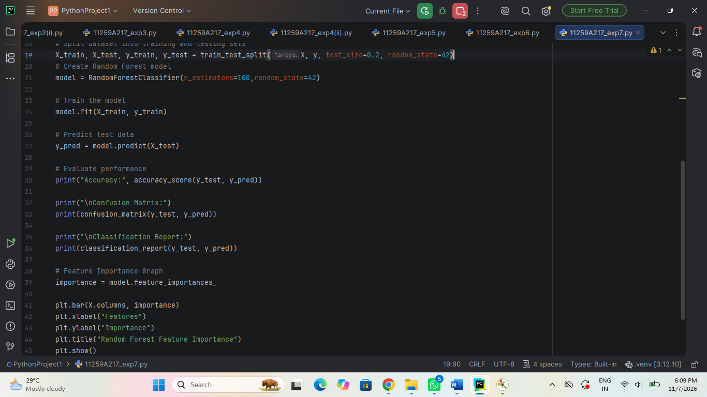

Output:

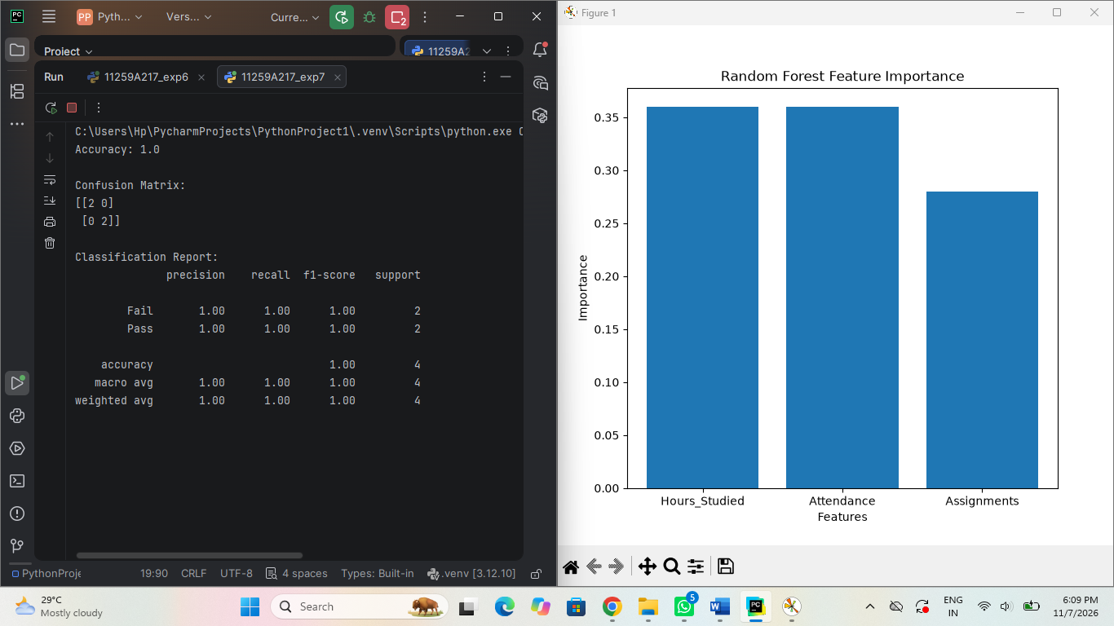

Result:

Random forest was successfully implemented and achieved good classification accuracy by combining multiple decision tress, resulting in improved and reliable performance.

EXPNO8: Implement Boosting Technique (AdaBoost) and Analyze Performance

AIM:- To implement the AdaBoost (adaptative learning) technique and analyze its performance in terms of classification accuracy and efficiency.

Algorithm:

- Start
- Load the dataset.
- Preprocess the dataset by handling missing values.
- Separate input features (X) and target variable (Y).
- Split the dataset into training and testing data.
- Create the AdaBoost classification model.
- Initialize equal weights for all training samples.
- Train the weak learner using training data.
- Increase the weights of incorrectly classified samples.
- Decrease the weights of correctly classified samples.
- Repeat the process to create multiple weak learners.
- Combine all weak learners to get the final prediction.
- Calculate evaluation metrics such as Accuracy, Precision, Recall and F1-Score.
- Analyze the model performance using graphs.
- Stop

Program:

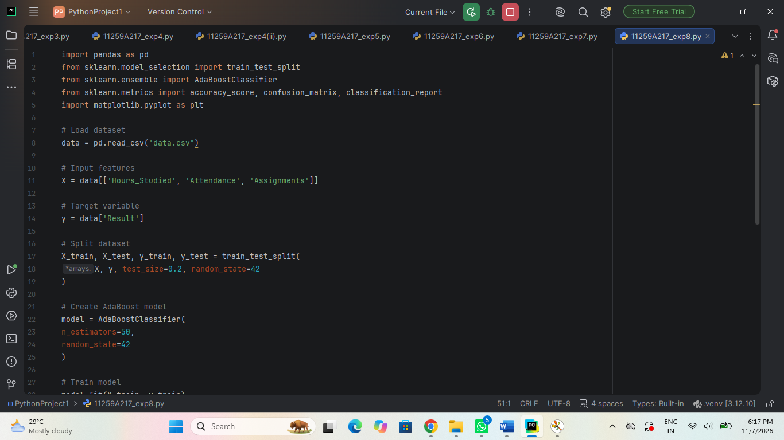

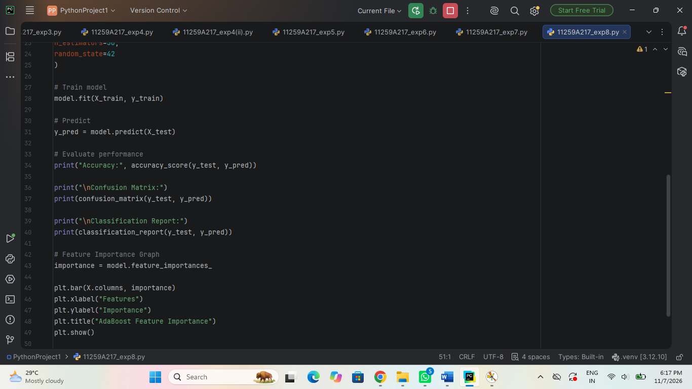

Output:

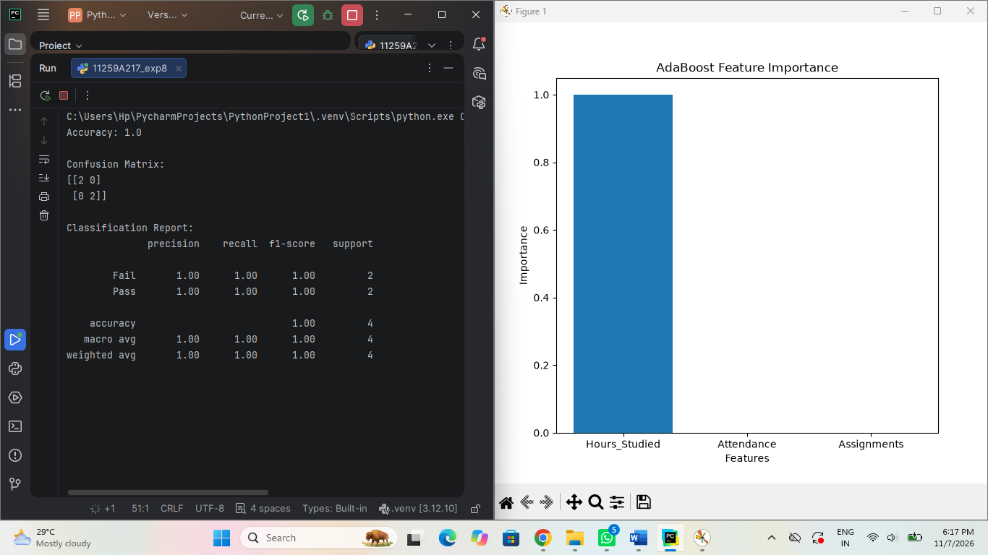

Result:

AdaBoost was successfully implemented and showed good classification performance with improved accuracy by combining multiple weak learners .

EXPNO9: Implement a Basic Reinforcement Learning Model (Q-Learning)

AIM:- To implement the Q-learning algorithm to train on agent generate the optical Q-table for finding the best based on the reward matrix .

Algorithm:

- Start
- Define the environment and initialize the Q-table.
- Set the learning rate, discount factor and exploration rate.
- Select the initial state.
- Choose an action using the exploration strategy.
- Perform the selected action.
- Observe the next state and reward.
- Update the Q-value using the Q-Learning formula.
- Move to the next state.
- Repeat the process until the goal state is reached.
- Display the learned Q-table and final results.
- Stop

Program:

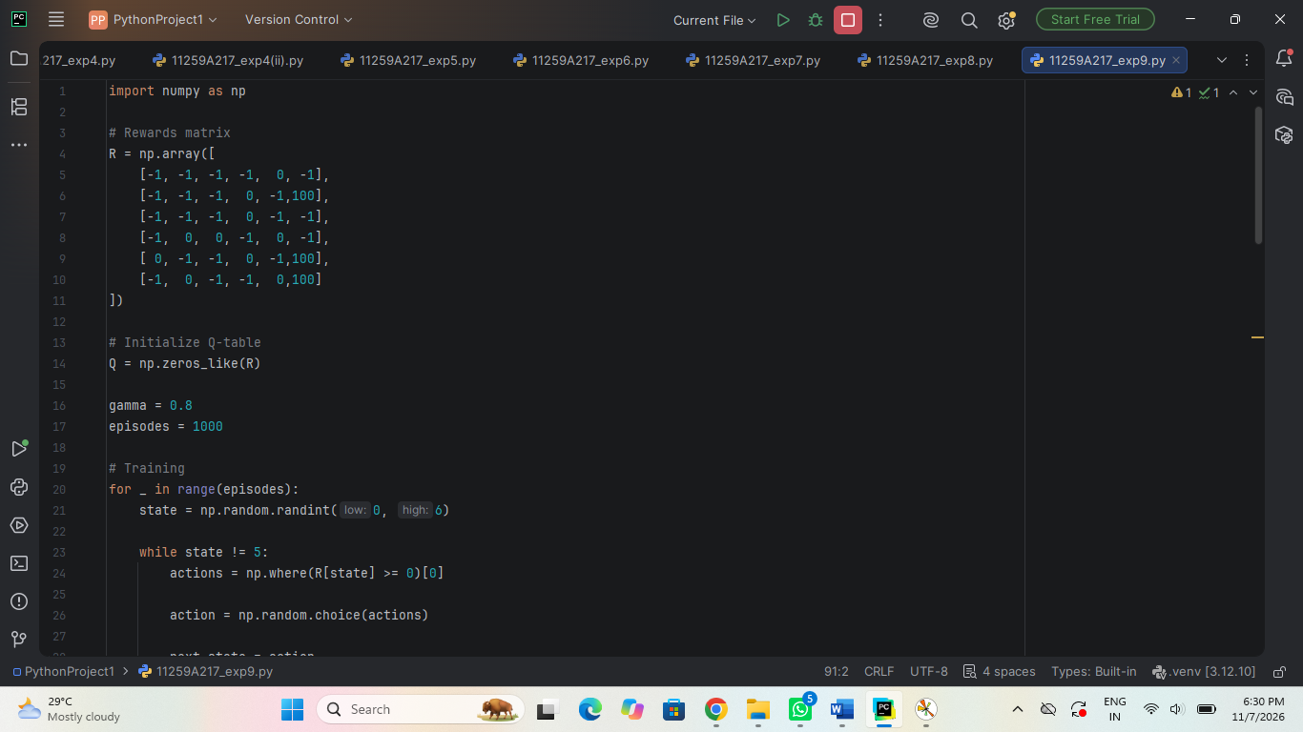

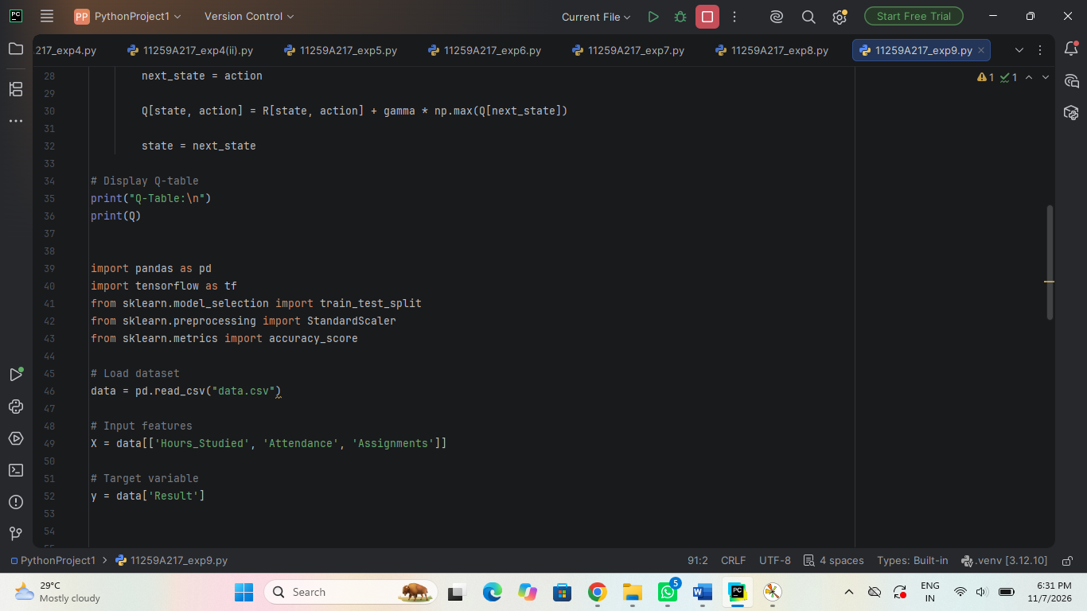

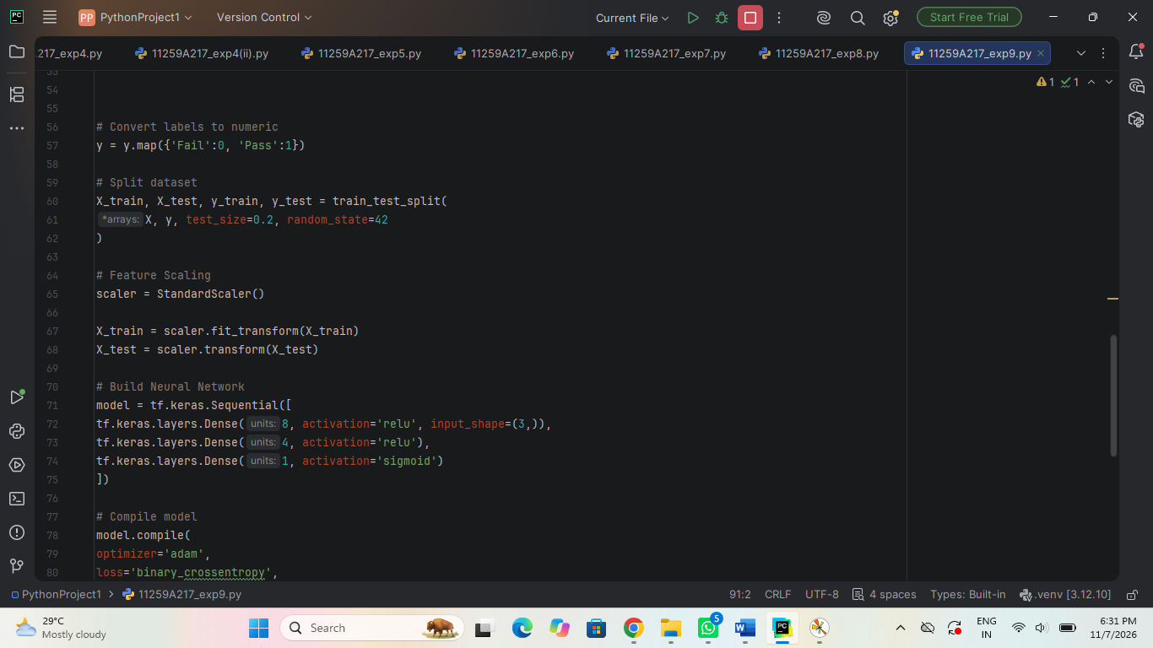

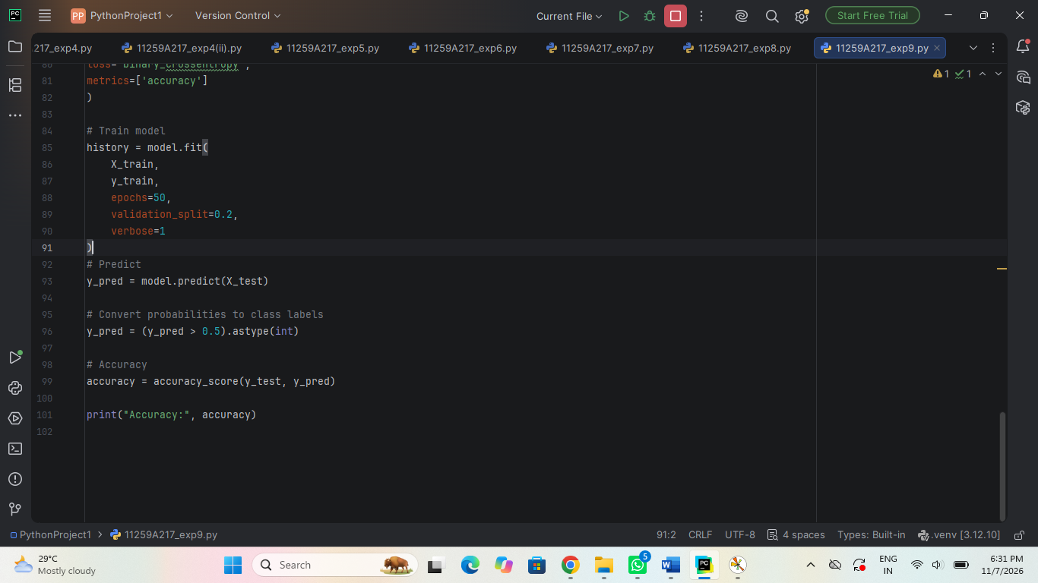

Output:

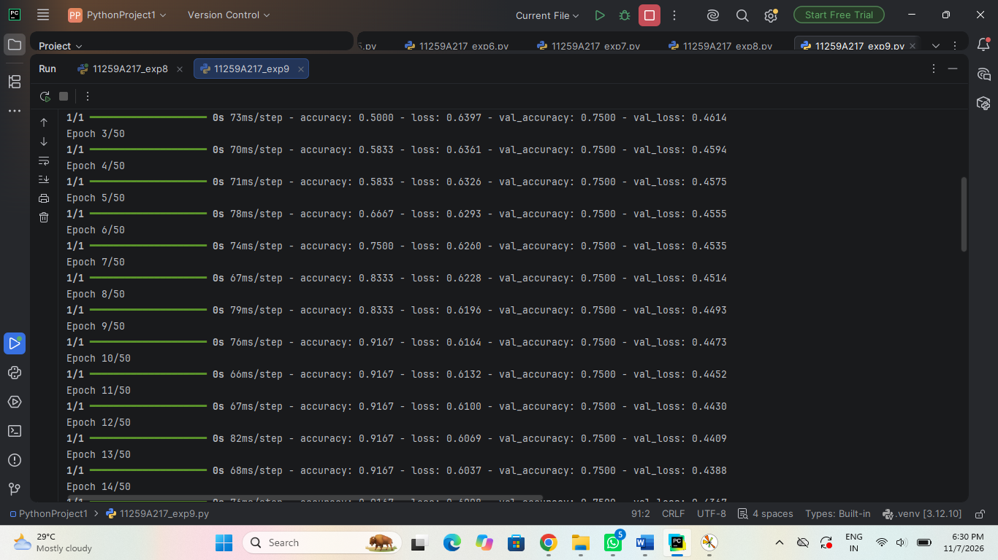

Result:

Thus, the basic reinforcement learning model using Q-learning was implemented successfully ,and the agent learned the optimal policy through rewards .

